Syntax:
- Basic php syntax is embedded in HTML which in short allows for php to run within HTML:
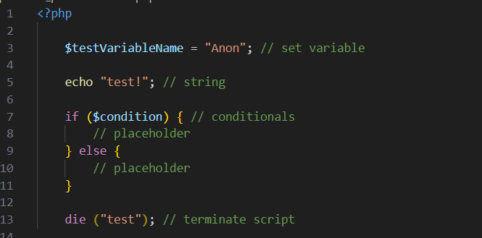

- Essentially, most of the syntaxes are similar to Python with a few new applications such as the ‘$’ for variable names.

MySQLi vs PDO
- “PDO will work on 12 different database systems, whereas MySQLi will only work with MySQLi databases. Both object oriented, but MySQLi also offers a procedural API” – W3schools

Functionality:
- Before you can connect to the database, you first must connect to the server. Below is how it can be done.
- Functionality view is as attached below:
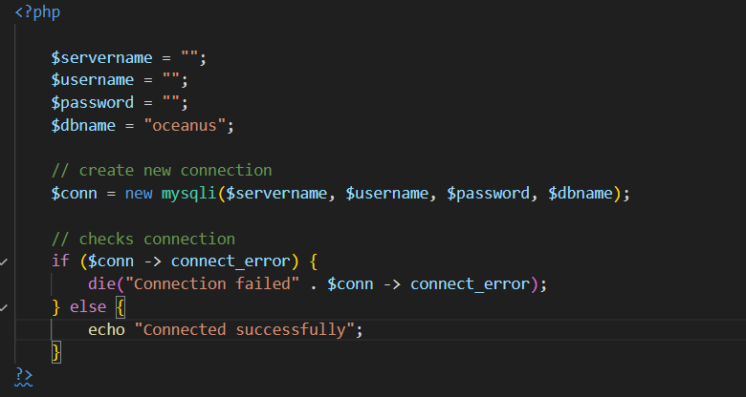

- Variables are created with the names for server, username, password, and database.
- A new connection will then be created using $conn.
- Conditional statement then follows and checks whether the connection is connected. If not, an error message will appear followed by the termination of the script. If a connection does happen, a message will appear stating that the connection has been connected successfully
- To close a connection, you will need to input:
$conn->close() where $conn is the variable name you used to create a new connection

Source: PHP MySQL Connect to database (w3schools.com)

